**Habits: Build better habits**

Requirement elicitation

Date: 3 February 2023

1. Use Case diagrams

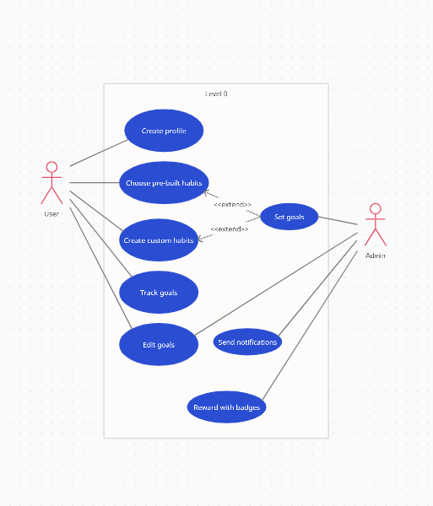

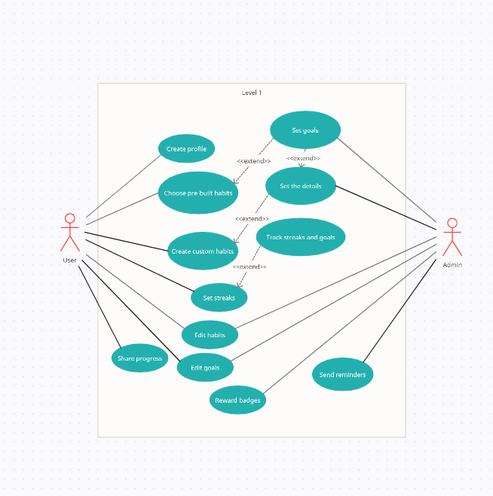

1. Sequence diagram

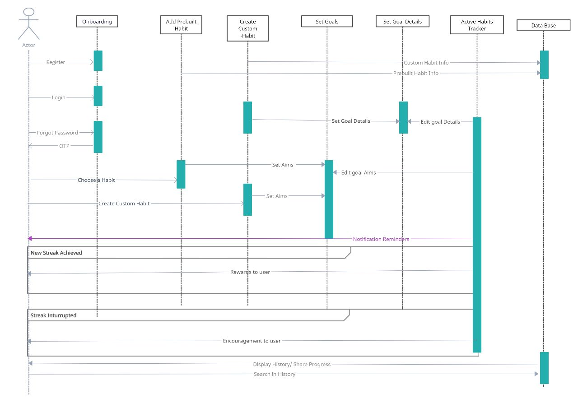

1. Class diagram

